1.Results and Analysis

**1.1. Outcomes of the implementation:**

The traffic light cycles through three states: red, yellow, and green. It turns on the red LED for 10 seconds,

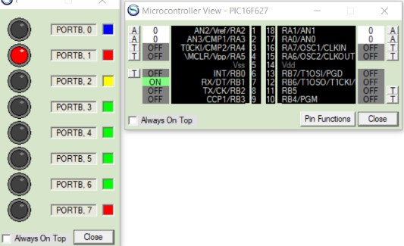

*Figure 2: 8 x LED board and Microcontroller view.*

then turns on the yellow LED for 3 seconds,

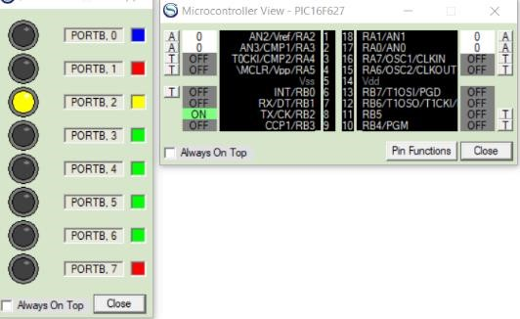

*Figure 3: 8 x LED board and Microcontroller view.* and then turns on the green LED for 10 seconds.

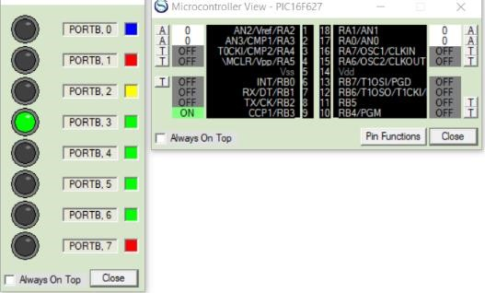

*Figure 4: 8 x LED board and Microcontroller view.*

The traffic light controller continually cycles through these states until the pedestrian button is pressed.

When the pedestrian button is pressed, it interrupts the normal cycle (mentioned above) and switches the traffic light controller to a pedestrian crossing state.

During the pedestrian crossing state, the pedestrian red LED turns on for 10 seconds and the yellow LED turns on for the vehicles. When a yellow traffic light turns on it alerts the drivers that a pedestrian is about to cross the road so that they can slow down their vehicles.

***NOTE****: The blue LED on the 8 x LED board is used to represent the pedestrian button.*

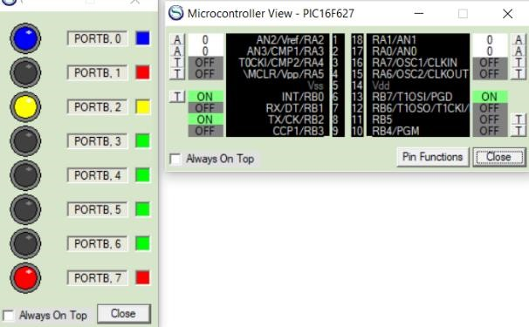

*Figure 5: 8 x LED board and Microcontroller view.*

After the pedestrian red LED turns on for 10 seconds, a pedestrian green LED turns on for 10 seconds and the red LED turns on for the vehicles. This will allow the pedestrian to safely cross the road.

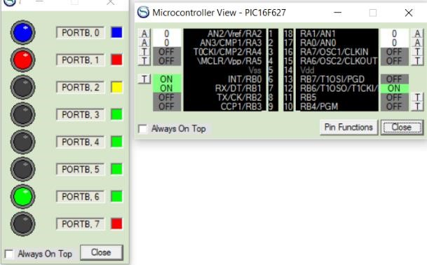

*Figure 6: 8 x LED board and Microcontroller view.*

After completion of the pedestrian crossing state, the traffic light turns to its previous state and continues its normal cycle.